First read the Web Technologies.
What was the server architecture?
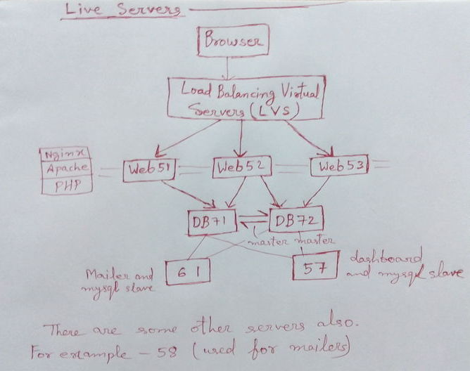
NGINX can handle around 50 times more requests per second than apache. So, our contact point from the users are NGINX. It passes the requests to Apache and then the requests goes to PHP.
Master/Slave is based on a Master sending an instruction to the Slave, then the Slave carries out that command.

What was the basic architecture of the application?
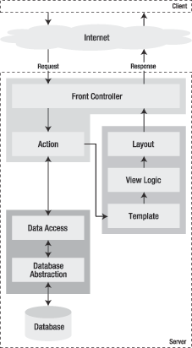

The Model part of the application:
data_abstraction.php
<?php
function open_connection($host, $user, $password) {
return mysql_connect($host, $user, $password);
}
function close_connection($link) {
mysql_close($link);
}
function query_database($query, $database, $link) {
mysql_select_db($database, $link);
return mysql_query($query, $link);
}
function fetch_results($result) {
return mysql_fetch_array($result, MYSQL_ASSOC);
}
?>
data_access.php
<?php
// Requiring the data_abstraction
require_once('data_abstraction.php');
function getAllPosts() {
// Connecting to database
$link = open_connection('localhost', 'myuser', 'mypassword');
// Performing SQL query
$result = query_database('SELECT date, title FROM post', 'blog_db', $link);
// Filling up the array
$posts = array();
while ($row = fetch_results($result)) {
$posts[] = $row;
}
// Closing connection
close_connection($link);
return $posts;
}
?>
The view part of the application:
Listing 2-8 - The Template Part of the View, in mytemplate.php
<h1>List of Posts</h1>
<table>
<tr><th>Date</th><th>Title</th></tr>
<?php foreach ($posts as $post): ?>
<tr>
<td><?php echo $post['date'] ?></td>
<td><?php echo $post['title'] ?></td>
</tr>
<?php endforeach; ?>
</table>
Listing 2-9 - The View Logic Part of the View
<?php
$title = 'List of Posts';
$posts = getAllPosts();
>
Listing 2-10 - The Layout Part of the View
<html>
<head>
<title><?php echo $title ?></title>
</head>
<body>
<?php include('mytemplate.php'); ?>
</body>
</html>
The controller part of the application (index.php):
<?php
// Requiring the model
require_once('data_access.php');
// Retrieving the list of posts
$posts = getAllPosts();
// Requiring the view
require('view.php');
?>

- One of the great advantages of a front controller is that it offers a unique entry point to the whole application. If you ever decide to close the access to the application, you will just need to edit the front controller script. In an application without a front controller, each individual controller would need to be turned off.
- Symfony makes things easy. While taking the best of the MVC architecture, symfony implements it in a way that makes application development fast and painless.
- First of all, the front controller and the layout are common to all actions in an application. You can have multiple controllers and layouts, but you need only one of each.
- The front controller is pure MVC logic component, and you will never need to write a single one, because symfony will generate it for you.
- The other good news is that the classes of the model layer are also generated automatically, based on your data structure. This is the job of the Propel library, which provides class skeletons and code generation.
- If Propel finds foreign key constraints or date fields, it will provide special accessor and mutator methods that will make data manipulation a piece of cake.
- And the database abstraction is totally invisible to you, because it is dealt with by another component, called Creole. So if you decide to change your database engine at one moment, you have zero code to rewrite. You just need to change one configuration parameter.
- And the last thing is that the view logic can be easily translated as a simple configuration file, with no programming needed.

How were you storing the resumes in the mysql databbase?
Using PHP to upload files into MySQL database sometimes needed by some web application. For the first step, let's make the table for the upload files. The table will consist of.
- id : Unique id for each file
- name : File name
- type : File content type
- size : File size
- content : The file itself
For column content we'll use BLOB data type. Since BLOB is limited to store up to 64 kilobytes of data we will use MEDIUMBLOB so we can store larger files ( up to 16 megabytes ):
CREATE TABLE upload (
id INT NOT NULL AUTO_INCREMENT,
name VARCHAR(30) NOT NULL,
type VARCHAR(30) NOT NULL,
size INT NOT NULL,
content MEDIUMBLOB NOT NULL,
PRIMARY KEY(id)
);

Uploading a file to MySQL is a two step process. First you need to upload the file to the server then read the file and insert it to MySQL.

For uploading a file we need a form for the user to enter the file name or browse their computer and select a file. The input type="file" is used for that purpose.
<form method="post" enctype="multipart/form-data">
<table width="350" border="0" cellpadding="1" cellspacing="1" class="box">
<tr>
<td width="246">
<input type="hidden" name="MAX_FILE_SIZE" value="2000000">
<input name="userfile" type="file" id="userfile">
</td>
<td width="80"><input name="upload" type="submit" class="box" id="upload" value=" Upload "></td>
</tr>
</table>
</form>
An upload form must have encytype="multipart/form-data". enctype='multipart/form-data' means that no characters will be encoded.
After the form is submitted, we need to read the php superglobal variables $_FILES. In the example above the input name for the file is userfile so the content of $_FILES are like this:
$_FILES['userfile']['name']: The original name of the file on the client machine.
$_FILES['userfile']['type']: The mime type of the file, if the browser provided this information. An example would be "image/gif".
$_FILES['userfile']['size']: The size, in bytes, of the uploaded file.
$_FILES['userfile']['tmp_name']: The temporary filename of the file in which the uploaded file was stored on the server.
$_FILES['userfile']['error']: The error code associated with this file upload. ['error'] was added in PHP 4.2.0.

Now our php file at the server end can put this file in the database table:
<?php
if(isset($_POST['upload']) && $_FILES['userfile']['size'] > 0) {
$fileName = $_FILES['userfile']['name'];
$tmpName = $_FILES['userfile']['tmp_name'];
$fileSize = $_FILES['userfile']['size'];
$fileType = $_FILES['userfile']['type'];

$fp = fopen($tmpName, 'r');
$content = fread($fp, filesize($tmpName));
$content = addslashes($content);
fclose($fp);
if(!get_magic_quotes_gpc()) {
$fileName = addslashes($fileName);
}
include 'library/config.php';
include 'library/opendb.php';
$query = "INSERT INTO upload (name, size, type, content ) ".
"VALUES ('$fileName', '$fileSize', '$fileType', '$content')";
mysql_query($query) or die('Error, query failed');
include 'library/closedb.php';

echo "<br>File $fileName uploaded<br>";
}
?>
Before you do anything with the uploaded file, always check to see if the file was successfully uploaded by looking at the file size. If it's larger than zero byte then we can assume that the file is uploaded successfully.
PHP saves the uploaded file with a temporary name and save the name in $_FILES['userfile']['tmp_name']. Our next job is to read the content of this file and insert the content to database. This way we can save the resumes of the user in the mysql database.
Downloading Files From MySQL Database: When we upload a file to database we also save the file type and length. These were not needed for uploading the files but is needed for downloading the files from the database. The process of downloading the file from the database is almost opposite to the process of uploading.

